Mummy Game Integration with LCMS

Integration Specification

Contents

[Overview 2](#_Toc328149488)

[Interface Builder 3](#_Toc328149489)

[Configuration XML 5](#_Toc328149490)

[Preview Mode 6](#_Toc328149491)

[Splash Screen 6](#_Toc328149492)

[Play Area – Question with Options 6](#_Toc328149493)

[Play Area – Feedback 7](#_Toc328149494)

[Review and Analyze Module 7](#_Toc328149495)

[Final Screen 8](#_Toc328149496)

# Overview

In this assessment template, the author selects mummy game to set data with the help of interface builder. Assessment game template gets data from the assessment bank item and display dynamically in the preview mode.

Assessment template has one XML Configuration file which is using purpose.

1. **Interface Builder Generator** – LCMS loads xml and generate interface according to it.
2. **Data holder** - template gets data from xml.

lcms_logo copy.jpg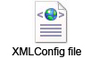

# Interface Builder

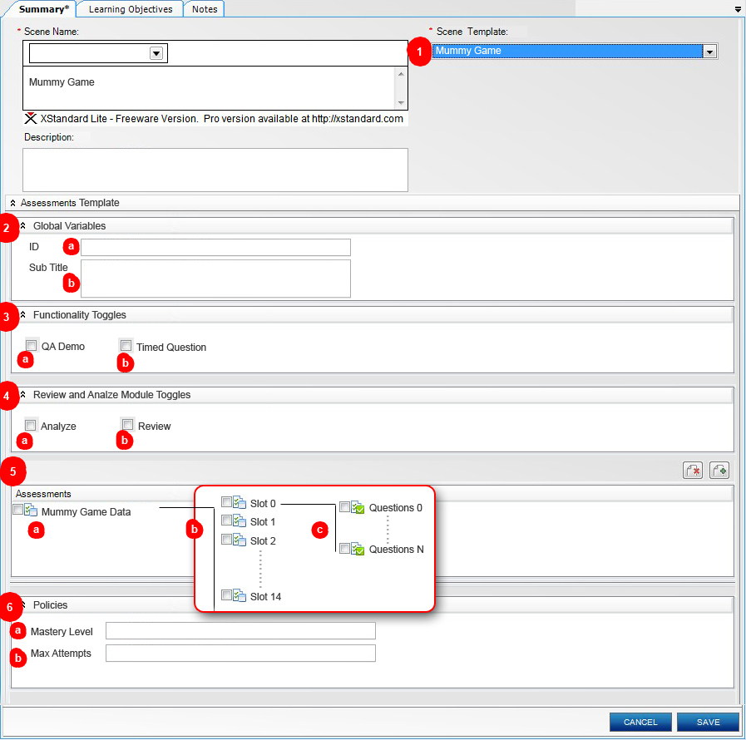

1. **Mummy Game** Assessment template.
2. Global Variables
   1. **Game ID** input text field.
   2. **Game Sub Title** text area.
3. Functionality Toggles
   1. **QA Demo Toggle** checkbox.
   2. **Question Timed Toggle** checkbox.
4. Review and Analyze Module Toggles
   1. **Review Toggle** checkbox.
   2. **Analyze Toggle** checkbox.
5. **Assessments** panel.
   1. **Assessment item bank** contains 14 child assessment item banks.
   2. **Assessment item** **bank** contains unlimited child assessment items.
   3. **Assessment item** contains multiple choices – Single select with four option choices and simple feedback.
6. **Policies**
   1. **Mastery Level** input text field.
   2. **Max Attempts** input text field.

# Configuration XML

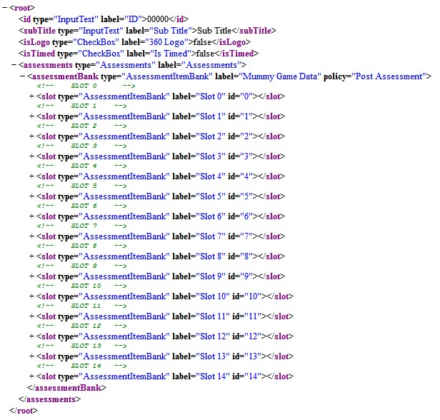

# Preview Mode

Splash Screen

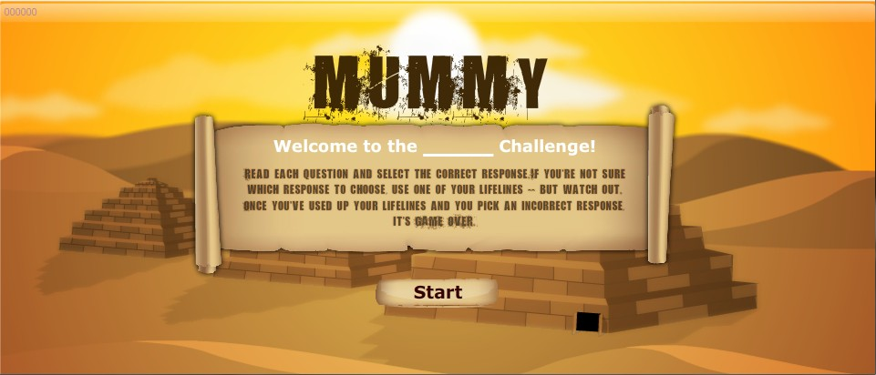

Play Area – Question with Options

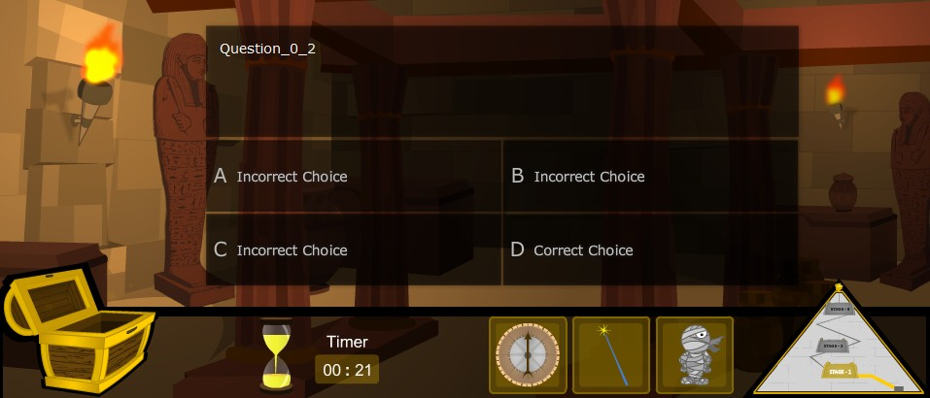

Play Area – Feedback

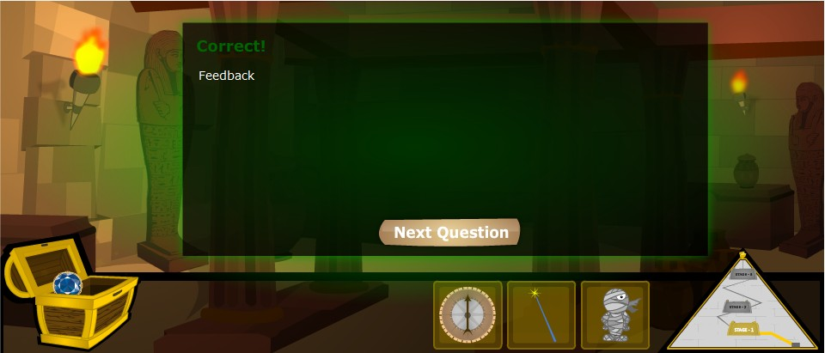

Review and Analyze Module

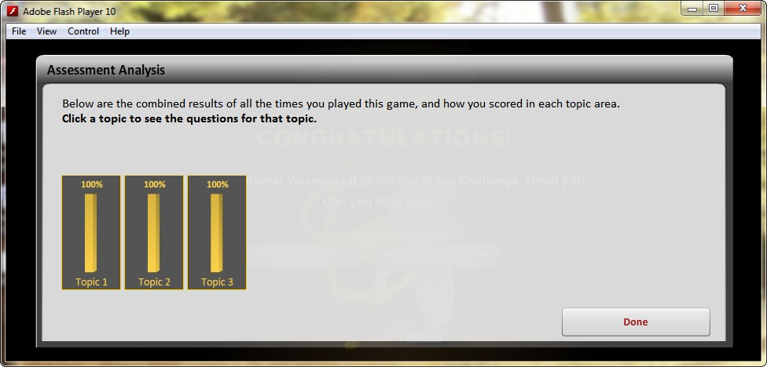

Final Screen

